**UNIVERSITY OF ENERGY AND NATURAL RESOURCES, SUNYANI, GHANA**

**SCHOOL OF SCIENCES**

**DEPARTMENT OF INFORMATION TECHNOLOGY AND DECISION SCIENCES.**

**TITLE:**

HEALTH MONITORING SYSTEM FOR EMERGENCY AND CHRONIC DISEASES.

A PROJECT WORK SUBMITTEDIN PARTIAL FULFILLMENT OF THE REQUIREMENT FOR DIPLOMA INFORMATION TECHNOLOGY, LEVEL 200

**BY GROUP THREE (3)**

Keziah Adoriba UED2708222

Mensah Iwin Tetteh UED2707822

Armo Bright Amponsah UED2704022

Kobbiah Patrick Adomako UED2703622

Shardey Hannah Yomle UED2703822

AUGUST, 2024

Table of Content.

Declaration iii

Certification iv

Acknowledgements v

Abstract vi

List of Figures ix

List of Tables x

Chapter 1: Introduction 1

1.1 Background 1

1.1.1 Case study of High and Low Blood Pressure 1

1.2 Problem Statement 3

1.3 Objectives 3

1.4 Scope 4

1.5 Significance of the Study 7

1.6 Organization of the Study 7

Chapter 2: Literature Review 9

2.1 Introduction 9

2.2 Health and Modern Lifestyles 9

2.3 Blood Pressure Management 11

2.3.1 High Blood Pressure (Hypertension) 11

2.3.2 Low Blood Pressure (Hypotension) 11

2.4 Important Findings: Heart Diseases in Ghana and Measures to Control Them 11

2.5 Further Findings Highlighting Key Challenges 14

2.6 Existing Health Monitoring Systems 17

2.7 Academic Projects 19

2.7.1 Pulse Rate Monitoring System - Final Year Project 19

2.7.2 IoT-based Health Monitoring System - Final Year Project 20

2.7.3 Smart Health Monitoring Vest - Final Year Project 20

2.8 Role of Health Monitoring Systems 20

2.9 Conclusion 21

Chapter 3: Methodology 23

3.1 Introduction 23

3.2 Rapid Application Development (RAD) Model 23

3.3 System Architecture 25

3.4 Software Components 26

3.4.1 Functional Requirements 26

3.5 Non-Functional Requirements 27

3.5 ER Modeling 29

3.6 Data Collection Methods 30

System Implementation 30

Testing Procedures 35

3.7 User Interface Design 36

3.8 Conclusion 37

Chapter 4: Results and Discussion 38

4.1 Introduction 38

4.2 System Functionality 38

4.3 System Demonstration 48

4.4 System Testing and Evaluation. 49

4.5 System Performance 50

4.6 Discussion of Findings 51

4.7 Challenges and Limitations 52

4.8 Summary 52

Chapter 5: Conclusion and Recommendations 54

5.1 Introduction 54

5.2 Limitations of the Study 54

5.3 Recommendations for Future Work. 54

5.4 Conclusion 55

References 57

# List of Figures

Figure 2. 1 Bono East region UHC scores within five districts 14

Figure 2. 2 Bono East region Prevention of health threats scores within five districts 15

Figure 2. 3 Bono East region Service Provision Capacity scores within four districts 15

Figure 2. 4 Bono East region Management Capacity-structure and systems scores in four districts 16

Figure 3. 1 Sytem Architecture……..……………………………………………………………24

Figure 3. 2 ER Diagram 27

Figure 3. 3 Data Flow Diagram 31

Figure 3. 4 Use Case Diagram 33

Figure 4. 1 Doctor's dashboard 49

Figure 4. 2 System overview and analytics 50

Figure 4. 3 Patient list 51

Figure 4. 4 Patient record 52

Figure 4. 5 Updating patient record 53

Figure 4. 6 Emergency list 54

Figure 4. 7 Emergency tracking 54

Figure 4. 8 Quick action and emergency alarming interface 55

Figure 4. 9 Account creation and login 56

Figure 4. 10 User dashboard 57

Figure 4. 11 Heart monitoring and real-time chat with doctor 58

Figure 4. 12 User health records 59

# ****Chapter 1: Introduction****

## ****1.**** ****1 Background****

## **It has become a major challenge to maintain optimum health in this evolving world we live in. As defined by World Health Organization (2023) health is a state of complete physical, mental and social well-being. It is not only disease-free but, even goes a step further than that. However, it has been observed that maintaining and attaining the state of ideal health is an area that is most vulnerable to current life styles and environmental challenges. Some things are inimical to our health. Due to work commitments or other habits most individual’s lead sedentary lives, which increase their risks to diseases such as diabetes, obesity, and cardiovascular diseases (Lee et al., 2012). He also notes that chronic diseases are also partly due to increased intake of processed foods containing high levels of sugar, salt and adverse fats (Micha et al., 2017).**

## **As mentioned by Schneider man et al., (2005), fatigue has a negative impact not only the physical and mental well-being; it also contributes to the different risks of disease such as heart disease, hypertension, and mental health disorders.**

## ****1.1.1 Case study of High and Low Blood Pressure****

## **Blood pressure is a good example of how the health impacting factors occur, as blood pressure is one of the essential cardiovascular figures. Blood pressure can again be either low blood pressure or high blood pressure. This diseases can be result from genetics which may be inherited form family history of Hypertension (Carretero & Oparil, 2000).**

**The other cause of high blood pressure is diet. High amount of salt intake, excessive alcohol intake and unhealthy diet lead to increased blood pressure (He & MacGregor, 2010). Lack of physical activity leads to a sedentary lifestyle also contributes to hypertension according to Wheaton et al. (2017) while chronic stress can lead to long term hypertension according to Spruill (2010).**

**This hypertension causes heart diseases that Increases the chances of getting heart attack and stroke (Benjamin et al., 2019). It can also lead to Kidney Damage, which may result in acute renal failure a long-time effect by Sarnak et al., 2003, vision loss that may harm blood vessels in the eyes, according to Baker et al., 2013.**

**Dehydration as a result of poor water intake is one of the causes of Hypotension Low Blood Pressure: Symptoms, Diagnosis & Treatment | National Heart, Lung, and Blood Institute (2022) Lack of vitamins such as Vitamin B12 and folate can cause problems such as slow heartbeat, heart valve disorders, or heart failure: Mader & Josephson (1991) Dis orders of the endocrine system like adrenal insufficiency: Ar**

**There are also numerous effects that Low Blood Pressure has; they include: Dizziness and Fainting that causes tripping and falling and injuring oneself (Mader & Josephson, 1991), Fatigue, the persistent tiredness that results from inadequate flow of blood to the organs (National Heart, Lung, and Blood Institute, 2022), and Shock.**

## In some occasion, to Mach low blood pressure may result in shock, which is a medical emergency (American Heart Association, 2021).

## Most of these health issues do not easily remit because there is little or no schedule for checkups. Most conditions are asymptomatic, and people do not seek treatment for them until the symptoms escalate (American Heart Association, 2021). Consequently, one’s health began to be checked routinely. Therefore, Health Monitoring System is easier to access and has minimizes complications of overall health status and major health complications due to high and low blood pressure.

## 1.2 Problem Statement

## Therefore the following are the main areas that seem to have some concern with the present Health Monitoring Systems. The World Health Organization in 2021 concluded that the vast population of the globe is in a state of unaffordable and efficient health monitoring equipment, which is foundational for screen and treat health issues. Further, Health Monitoring Systems have a limited Emergency Response at the present. Lack of proper emergency contacts notification and providing accurate location also leads to shortage of providing necessary assistance during medical emergencies and this appear to be a challenge.

## Out of the current health monitoring system some of them aids in maintaining records of health but are full of complications in handling health data. Many a times, using and understanding as well as processing health data becomes a challenge for the users to follow the latest trends and make suitable decisions (Anderson, 2019). Because of that, lot of people, especially patients with chronic diseases, fail to take their medications as prescribed, which may worsen their conditions (Jones & Smith, 2020) and this also requires Medication adherence functionalities.

## 1.3 Objectives

**Main Objectives**

1. The objective of the proposed system was to make the monitoring of heart rates an affordable means utilizing the smartphone camera.

2. In order to allow users to share their location with their emergency contacts easily and effectively, that is to help users get medical help as soon as possible.

3. to monitor and record users’ heart rate and allow them to monitor the future trends regarding their health.

4. To provide users with custom health advice and Dos and Don’ts for specific time of the day helping them to improve their health condition by taking pills on time.

**Specific Objectives**

1.Camera-Based Heart Rate Monitoring: Finally, it is possible to point that smartphone main feature – its camera – can be used for tracking and analyzing the heart rate without the necessity of having more devices.

2. Emergency Location Alerts: Let people share their current location with other contacts or an administrator during epidemics.

3. Real-Time Location Tracking: Make use of maps to facilitate constant monitoring of the user’s position to guarantee first responders reach the user efficiently.

4. Heart Rate Data Logging: This should also capture real time heart rate data to assist health conscious users monitor their progress and pass such details to doctors and healthcare professionals.

5. Health Tips and Reminders: Alarm users with health tips and or remind them of the need to take their medicine for enhanced health improvement.

**1.4 Scope**

The Health Monitoring System focuses on the following specific functionalities:

**•Camera-Based Heart Rate Monitoring:** Since the focal US of the proposed system is to check and evaluate the heart rate without integrating other wearable devices, it will employ the camera of the smartphone. It means that users could easily and fast evaluate their heart rates by means of this functionality.

**• Emergency Alerts:** In medical circumstances, patients will also be able to employ some of the functions within the system, where they are able to send an administrator or contact persons their location. In this way, the users will be able to quickly let someone who will ensure that the necessary medical help be given.

**•Real-Time Location monitoring:** The incorporation of maps in the system will enable tracking of the geographical location of the user at any one time. During situations this function will enable the user to be easily and effectively located by the emergency services.

**•Heart Rate Data Logging:** This is made possible through recording of the heart rate data in order to capture the long-term trend of the health of a user. The users will be able to review and analyze this data in order to discover something about their heart, should they wish to consult with a doctor.

**•Health Advice and Reminders:** To foster a better lifestyle the system shall provide the user with health advice. It also would ensure the users had an option of prescribing reminders for the prescribed doses in order to enhance overall health and retain specific treatments.

**Health Monitoring System**

As the following few health issues can be partially resolved through the provision of convenient and frequent Health Monitoring System. The following functionalities are included in the system:

**•Early Detection:** Its normal rhythm check assists in early dawns of the irregularities of the pulse that might suggest high or low blood pressure to users to seek medical attention.

**•Emergency Alerts:** The Cut to connect feature ensures that users can, in an emergency, quickly notify contact people with a medical problem so that an immediate medical response can be provided.

**•Health Advice:** Besides promoting a healthy lifestyle by helping users adopt better exercise and eating habits, the system provides health tips regarding high and low blood pressure risks.

**•Medication Reminders:** Patients should always stick to their prescribed dosage of a particular medicine in order to avoid problems or to treat an illness such as hypertension.

**• Health Status Tracking:** Also from the system, users can observe their overall wellbeing with time. This includes having to monitor blood pressure, pulse rate and many other factors of a patient.

**•Health Insights and Analytics:** The system therefore provides users with suggestions, analyses and results together with health data and allows the sharing of data with healthcare providers. These guarantees doctors to have sources of information that are current and real for purposes of making right diagnosis and handling of the patients.

**•Data Logging and Analysis:** The fact that heart rate and other health related data can be constantly measured, followed over time, it is helpful when diagnosing and treating diseases.

With ease of access to health monitoring intertwined with emergency response, health status tracking and health insights &analytics, Health Monitoring System is central to advancing overall health conditions and averting dangerous diseases linked to high and low blood pressure.

**1.5 Significance of the Study**

The profound meaning of this heath monitoring system is that it can help to improve the state of Health and increase emergency response readiness. The system also promotes personal initiatives toward the stewardship of one’s health (see Doe, 2018) through making heart rate monitoring less costly and more convenient. All the features of the emergency response include a function that enables users to get prompt medical help, which can make a difference between life and death in some cases (Miller et al., 2017). But the data logging and the health tips functions are those that enable people to stay on the right course and keep them healthy which is the objective of a good health meal plan and this has been attributed by Johnson and Brown (2019).

**1.6 Organization of the Study**

This research work comprises five chapters

**Chapter 1: Introduction**

This chapter provides background information for the Health Monitoring System, research issues, purpose and sample of the study, and the relevance of the HMS. There is also a presentation of a summary of the study and the objectives as well as the delimitation of the research work.

**Chapter 2: Literature Review**

This chapter provides an overview of the health monitoring systems addressing current existing technologies, methodologies and gaps in the current studies. It describes the theoretical background of the research conducted for the present work and presents work that is related to the development of the system.

**Chapter 3: Methodology**

This chapter includes the description of the conducted research, sources of data accumulation and analysis procedures. It explains how system development has been done in terms of choosing technologies and tools and it presents the testing strategies that were used to assess the performance of the system.

**Chapter 4: Results and Discussion**

Thus, the results of system testing and users’ feedback are reflected in this chapter of the given study. It addresses issues on efficacy, difficulties faced, and effects on self-health administration for individuals using the system. The chapter also shapes the system with other solutions and then assess the effectiveness of the highlighted approach.

**Chapter 5:**

**Department Conclusion and Recommendations**

The last chapter gives a brief of the study conclusions, the weaknesses of the work in addition to suggestions for other progressive research on the topic. Lastly, its outcomes for self-health management is discussed along with insights regarding advancements in and future directions for the system.

**Chapter 2: Literature Review**

**2.1 Introduction**

In the area of health monitoring systems the health care industry has greatly benefitted from technological enhancement. All these systems from simple devices that can be worn to more complex smart phones are all designed to enable real time monitoring and control of various health indices. Thus, to provide a comprehensive understanding of the features, benefits, and shortcomings of several present-day health monitoring systems, this paper considers a number of them concerning both commercial and academic projects. In addition to pointing out these shortcomings, this evaluation will also indicate how our system will try to bridge these gaps in these systems.

**2.2 Health and postmodern lifestyle**

According to the World Health organization (2023) health is not merely a state of medical immunization from disease and incapacity but a complete physical, mental, and social well-being. However, practicing overall wellbeing receives challenges due to modern living. In most regions of the world, they include inadequate physical activity, poor diet, lack of energy and pollution of the environment.

**Sedentary Lifestyle**

Common knowledge tells us that reading through a day causes bad effects to the health. As pointed out by Lee et al. (2012), one of the main determinants for non-communicable diseases including diabetes, cardiovascular disease, and several types of cancer are lack of physical activity. Their survey concludes that removing physical inactivity would increase global life span. So it stresses on how effective exercise is as a means of encouraging good health and the need to avoid the various forms of diseases.

**Unhealthy Diet**

The interaction between diet parameters and cardiovascular disease, cerebrovascular accident, and diabetes mortality is discussed by Michal et al. (2017). These authors, therefore, identified these problems as being seriously compounded by low diet quality, which they described as a high consumption of processed foods with high content of sugars, salts, and undesirable fats. There is therefore need to review and strengthen dietary measures and nutritional policies that will help to halt the increased incidence of diet related chronic diseases.

**Stress and Health**

A third measurable construct contributing to stress is chronic stress. The nature of the psychological, behavioral, and biological factors is reviewed by Schneiderman et al. (2005) which are known to be changed by stress. It is at this point that they say that long term stress leads to mental complications, heart illnesses, and high blood pressure. The physiological stress response also produces hormones such as cortisol and adrenaline, and sustained levels of these hormones are toxic to the cardiovascular system and the other systems of the body.

**Environmental Pollution**

The effects of air as well as water pollution on cardiovascular health are discussed by Brook et al. (2010) who also highlights how environment affects health. They state that the particulate matter arising due to pollution can engender body inflammation, leading to diseases such as heart diseases and high blood pressure. Based on their discovery, high standards of environmental legal frameworks are required to reduce pollution and protect the population.

## 2.3 Blood Pressure Management

## 2.3.1 High Blood Pressure (Hypertension)

## Basic Types of Cardiovascular Diseases: High Blood Pressure (Hypertension)

## However, one major concern for public health is high blood pressure. Carretero and Oparil (2000) have pointed out that the major contributors to hypertension include stress, diet, physical activity and heredity. He and MacGregor (2010) particularly speak about the effects that the consumption of salt causes hypertension and advocating for a reduced use of salts across the food chain as a practical strategy to achieve lower blood pressure and … protect against cardiovascular diseases.

## Hypertension is not only bad for your health, but it has some side effects as well. Benjamin et al. (2019) noted that when blood pressure is high there is likely to be kidney failure, heart attack, and stroke. Baker, et al. (2013) states that the condition of high blood can negatively affect the blood vessel in the eye, leading to blindness. This destruction draw the outcomes of the importance of the constant screening and effective control of hypertension.

## 2.3.2 Symptoms Resulting from Diseases and Conditions

## Low Blood Pressure (Hypotension)

## While people tend not to discuss hypotension, or low blood pressure, this condition can also have severe effects. Based on the National Cardiac, Lung, and Blood Institute (2022), hypotension is mainly brought about by conditions such as dehydration, nutritional deficiencies, and cardiovascular or endocrinological problems. Deconditioning involving low blood pressure when defined by Mader and Josephson in 1991 involves weariness, dizziness and fainting, which leads to falls and injuries. In severe cases, there can develop a state known as shock, which can be fatal.

## 2.4 Important Findings: AIDS and Measures Taken to Prevent It in Ghana

## There is an increased incidence of heart diseases in Ghana that has given proportionally a massive contribution to the increased burden of NCDs in the country. CVDs diseases; which encompasses heart disease are among the top killer diseases in the world and Ghana included. NCDs constitute 43% of total deaths in Ghana; heart diseases are prevalent, with hypertension as a cause by WHO, 2019. The observed epidemiological shift and the growth of CVDs in the country are traceable to socio-economic factors, Democracy, Urbanization and nutrition transition, sedentary lifestyles, and increased tobacco and alcohol use.

## Research on the prevalence of hypertension in Ghana by the Ghana Health Service puts hypertension prevalence in Ghanaians at 28% and associates hypertension with heart disease (Ghana Health Service, 2023). That is rather worrisome, especially, looking at the threat in relation to the Bono East Region, where the prevention has been Recorder to have been of; varying success some districts record as low as 38% (Ghana Health Service, 2023). Such figures underscore the importance of integrated approaches for the prevention and control health related issues such as heart diseases.

## As this becomes a rising challenge in public health on Ghana, there have been set strategic approaches. Efforts to educate people about the dangers associated with heart diseases have been escalated and so have endeavors meant to encourage healthier living. These campaigns are important as they foster increase in use of well-proportioned foods and exercises, decrease in use of tobacco and alcohol which are behavior change approaches that are instrumental in combating the increase in cases of heart diseases (Ghana Health Service, 2023; PLOS Global Public Health, 2022).

Along with awareness programs there has been a considerable overtures to the extension of easy access to health checkups as well as early diagnosing of hypertension and other potential cardiovascular disease risks. Screening is also important to meet with people at risk and addressing their problems before they escalate into major illnesses. From the perspective of the Ghana Health Service, these innovations are meaningful to increase the number of Ghanaians who have the information about their health and thus be able to act properly on their well-being (Ghana Health Service, 2023).

Enhancing the quality of health care as well as the accessibility to such services in arid and hard to reach areas has also been in the central agenda of the Ghanaian government. This is for the improvement of health facilities; and to ensure that patients with heart ailments get the right attention in the right time. Among other things, it involves educating care givers on the modern management of cardiovascular diseases and increasing availability of requisite drugs. These efforts are backed by policies intended to lessen the toll of NCDs through better nutrition, such as food labeling, and like tobacco control and increased physical activity through better urban design and creation of public space (World Health Organization, 2019).

However, a number of challenges persist even after these what I have termed as complete measures have been made. Many still lack adequate health care embracing with several barriers back up in infrastructural developments and cultural practices that slow down the provision of health care. Also current challenges like high battery consumption in portable health monitoring devices as a concern that more innovative products are required in the health management field to enhance sustainability and utility (Ghana Health Service, 2023).

Therefore, though Ghana has strides in the reduction of burden of heart diseases, much more needs to be done in order to eliminate these challenges. I will therefore recommend that great pains be made toward more research and monitoring, followed by the making of changes in ways that will see the rates of heart diseases decreasing even further and the general heath of the people of this Nation, Ghana improving.

**2.5 Other Findings which Captures Core Issues**

Here are some charts extracted from other information as follows

Figure 2. 1 provides Bono East region UHC scores in five districts retrieved from further findings

Figure 2. 1 chart shows Bono East region UHC scores within five districts.

Figure 2. 2 chart is the Bono East region prevention of health threats in five districts.

Figure 2. 3 represents the Bono East region Service Provision Capacity in four districts.

Figure 2. 4 chart shows Management Capacity-structure and systems scores of Bono East region in four districts.

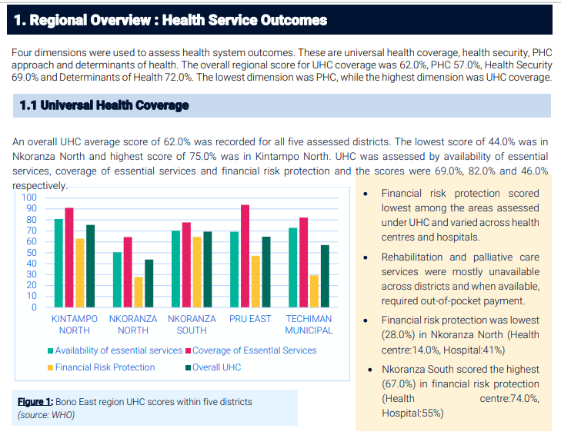

Figure 2. 1 Bono East region UHC scores within five districts

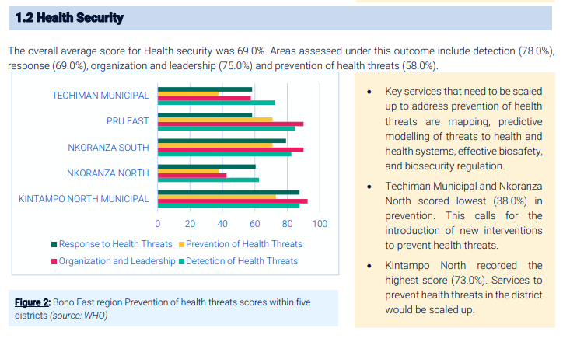

Figure 2. 2 Bono East region Prevention of health threats scores within five districts

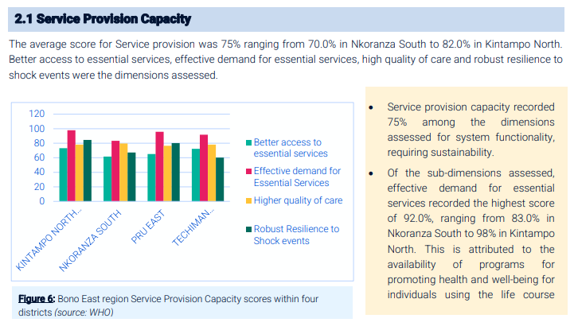

Figure 2. 3Bono East region Service Provision Capacity scores within four districts

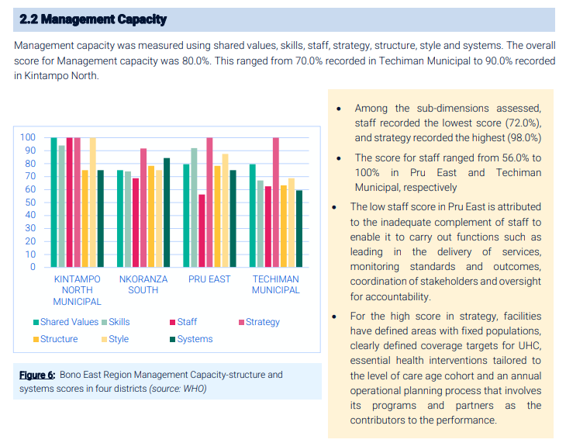

Figure 2. 4 Bono East region Management Capacity-structure and systems scores in four districts

* **2.6 Current Systems for Health Monitoring**
* **Fitbit**

It is a popular wearable technologies-based company, very popular for its wide range of facilities in fitness and health. The gadgets track various parameters such as heart rate, sleep, daily or overall activity levels and much more. According to the data collected, the mobile application span Fitbit provides clients with personal feedback and analysis. By applying challenge and reminder tools, the app helps users to indicate their desired fitness goals, monitor their progress and keep them motivated. Similar to the general health, Fitbit has added functionalities where it synchronizes with other health applications, as well as devices (Fit bit, 2023).

* **Apple Health**

It is a health-related application compatible with iOS which gathers health data from Wearable, Fitness apps and Medical devices etc. It includes steps count, pulse rate, sleep, diet plan, and even the level of mindfulness person has. To start with, first responders may turn to the health information by using the emergency services that include Medical ID on the app. Moreover, Apple (2023) eats of Health Records that assist its customers in making better health-related decisions since it compiles and shares their medical data to the professionals.

* **Samsung Health**

Samsung Wellness is an adaptable fitness and wellness program available only for Samsung devices. It tracks some of the health parameters like pulse rate, sleeping cycle, stress and diet plans. It helps create sticking to vow through functionalities such as challenges, motivation, and social network connectivity and advises on health and exercising. Moreover, Samsung Health also allows for a third-party health device and application that can be connected with the consumers as a way of giving the broad health view (Samsung, 2023).

## • Garmin Connect

## Garmin connect is an app for health and fitness designed for Garmin wearables only. Besides the motor activity of the user, it monitors the pulsation, sleep cycle, and other aspects to offer the user all the necessary information and become an effective tool for making him/her get better and work actively. To promote engagement and motivation the system provides usage of social aspects, incorporation of fitness elements and individual workout schedules. Due to the measurements and analysis of performance by the Garmin Connect it is more preferred by athletes as well as fitness freaks (Garmin, 2023).

## • WHOOP

## As an activity monitor, WHOOP is developed to amplify exertion and rest. It is able to monitor the strain, the heart rate variability, and the sleep stage which helps the users give them information about their level of recovery and fitness preparedness. To assist users, enhance the outcomes of their training, as well as avoid overtraining, WHOOP uses personal training and suggestions derived from the data collected. In this way, athletes and other fitness-conscious people use the gadget and the corresponding app to manage the recuperation and, in turn, the performance (WHOOP 2023).

## •Withings Health Mate

## Withings is a company that deals with smart devices including smart weight scale, blood pressure, multifunctional activity trackers and other gadgets that are integrated into health and fitness software called Withings Health Mate. The app also gives estimated health details and check ups base on concerns like blood pressure, weight, sleep, activity, heart rate among others. Currently serving as a full health management companion, Health Mate integrates with other fitness and health applications and enables the transfer of information to medical professionals (Withings, 2023).

## 2.7 Academic Projects

Pulse Rate monitoring System, considered as the Final year Project of this thesis is given below Oral Presentation the 7th and last proposal of the thesis is as follows:

**2.7.1 Objectives**

The main objective of this final year project is to develop pulse rate monitoring system that consists of microcontroller, pulse sensor and display module. Pulse rate of the user has been integrated within the system that displays the result on an LCD panel in real-time basis. Designed with it is an alert system which will notify the user if the pulse rate goes beyond a particular threshold. The project aims at providing a widely accessible and relatively affordable technique for heart rate monitoring, especially in regions with limited local access to technological advanced medical facilities (Adebayo, 2019).

**2.7.2 IT-based Health Monitoring System**

A plan for the use of the Internet of Things for tracking creditable health indicators, such as blood pressure, body temperature, and pulse rate is being developed. The use of sensors wired to the microcontroller that uses the web connection to transmit the data to the cloud server is applied. Patients can interact with a page on the website or a specially developed application to receive health data. Kumar and Singh (2020) also state that the task is to provide constant health supervision and to inform the users and health care providers about the deviations, so that they can immediately respond.

**2.7.3 Smart Health Monitoring Vest:**

For this project, an app for health monitoring together with the sensor to monitor temperature, pulse and other vital signs will be used. This sensor information is received and analyzed by the microcontroller that is sited on the vest before relayed over Bluetooth to an application in a smartphone. Users will see the data in real-time and the software will alert them if any of the data are beyond their range. The project’s goal is to help patients mainly the old and chronically ill—a convenient way to manage their health (Patel & Sharma, 2018).

**2.8 Function of Health Monitoring Systems**

Health tracking systems play their part in dealing with health challenges posed by modern living schemes. According to the American Heart Association (2021), with normal health check-ups, it is easier to recognize the problems, such as abnormal heart rate, which might be a sign of hypotension or hypertension in the initial stages. Prolific Symptoms and Assertive Response Cardiovascular issues can be easily diagnosed at an early stage if the health monitoring equipments were to include attributes such as pulse rate. Early detection is said by the American Heart Association (2021) to allow for an appropriate response to be taken before adverse health effects set in.

**Heath Information and Medication Prescriptions**

## Another essential use of heath monitoring systems is to give health advice unique to the patient and to remind those using the systems about their medications. Several NIH’s (2022) argue that such features ensure compliance with the dosages and make it easy to embrace good habits that control diseases like high blood pressure.

## Health Status Tracking

## Through trends drawn on the lives of a certain product group, the consumers or health practitioners can detect certain signs such as the blood pressure rate of the consumers regularly checking it. This is a key factor towards improved literate healthcare decisions, and overall chronic illness management (American Heart Association, 2021).

## Health Insights and Analytics

## Bridging health intelligence and analytics into monitoring systems make health insights and detail available to consumers and healthcare providers. Such data make healthcare delivery more successful by interventional and treatment giving to the needful patients (National Institutes of Health, 2022).

**2.9 Conclusion**

The paper reveals potential loss of health due to certain lifestyles and potential use of health monitoring systems. These technologies have the potential to bring health and effectively manage chronic diseases with the ability to detect, respond to, monitor and understand health status and health guidance.

**Chapter 3: Methodology**

**3.1 Introduction**

This chapter focuses on the procedure adopted in the development of Health Monitoring System, concept formulation and implementation process, and the result of the system. This section provides the information of system design and software resources, the methods for data acquisition, strategies for system implementation, testing paradigms and assessment techniques Constituting the methodology part**.**

**3.2 Rapid Application Development – RAD Model**

The Health Monitoring System is developed adopting an RAD (Rapid Application Development) model. The method pays a great deal of attention to the speed of development and entails users’ involvement actively. That’s why we chose the RAD methodology because its approach is closer to Iterative development and fast prototyping. This RAD approach has included the following stages, which we have followed through to the success of this project:

**1. Requirement Planning Phase:**

From the requirement phase, as described earlier, we conducted research on challenges and also brainstormed on the identification of the major challenges that still persist in the various health facilities and systems available for use in Ghana. We also engaged in a one on one conversation with some of the professionals in the health sector. We then defined a set of user requirements and from there we established goals and scope of the entire project.

**2. User Design Phase:**

From the user information needs, we have even developed the prototypes and we have also displayed some useful diagrams including Data Flow Diagrams (DFDs), Entity Relation Diagrams, and other useful diagrams which I also incorporate later in the chapter.

We enhanced designs with the feedback received from the users which were being collected in a more frequent way.

**3. Construction Phase**

Based on the prototype we have constructed the actual system, integrated all the parts and performed some preliminary evaluation.

**4. Transition Stage**

In the Transition phase, we have closed the system and put it on fully tested live situation.

We then offered assistance and some level of training to a few general users.

Figure 3.1 shows the System Architecture of the project.

In the next part of this chapter, you will now have a summary of what occurred for each development phase.

## 3.3 System Architecture

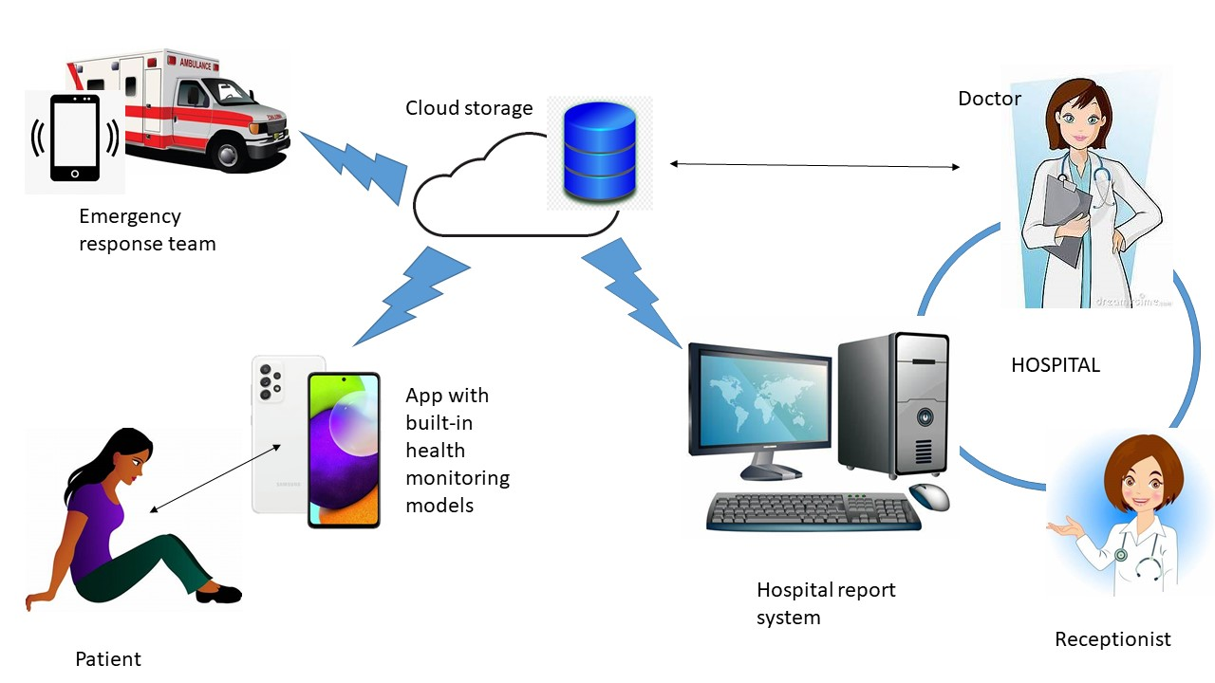

Figure 3. 1 System Architecture

The options that Health Monitoring System will include are Emergency Alerts, Medication Reminders, Health Advice and the constant monitoring of the health criteria. The general architecture will include several basic components:

1. Mobile application: Data visualization user interface, emergency alerting, prescription refill, disease counseling

2. Web application: it will generate a page allowing the doctor to monitor the various aspects about the health of the patients as well as trends within and suggest necessary action.

3. Server: This will execute the application logic and it will store and process data.  
4. Cloud Storage: It will Supports data analytics and serves as a storage of past health data.  
**3.4 Software Components**  
1. Mobile Application: It is designed to be patient-friendly and was developed using the cross-platform framework, Flutter.  
2. Web application: It is supposed to offer the administrator and physician an easy-to-use interface. The front-end development has been performed with the help of AJAX.js and PHP in the back end.  
3. Server-side Application: The application offers business logic, data processing, and storage via a backend framework. PHP can be used to develop the server-side application.  
4. Database: Data regarding the health status of the users will be stored in (MySQL), which is a relational database.  
**3.4.1 Functional Requirements**  
The following are the functionalities that can be implemented in the Android app, including but not limited to the following:

Registration and Authentication of a user: who can create his account, log in, and manage his account.

Health Monitoring: continuous heart rate and other health parameters using mobile sensors; Health Advice: given to the user according to his information and trends; medication reminders-consumer can set up and receive medication reminders.  
1. Emergency Alerts: In the event of an anomaly, send that to the administrator of the location of the user  
2. Data Visualization: On Mobile and web show the trends and analytics about health data

3. Server: This will perform the application logic and it will store and manipulate data.

4. Cloud Storage: It will assist in data analysis and also serve as repository data of health data that has been obtained in the past.

**3.4.2 Software Components**

1. Mobile Application: It is patient-friendly and the app was built using the cross-platform development framework, known as Flutter.

2. Web application: From it, it is supposed to present a user interface that is quite understandable to the administrator and the physician. The front-end development has been done with the help of AJAX.js while, the back end of the site has been created using PHP.

3. Server-side Application: The application has the component of business logics, data processing, and storage along with a backend framework. PHP can be used to make the server side application.

4. Database: Information concerning the information status of the users will be received and archived in MySQL which is a relational database.

**3.5 Functional Requirements**

The following are the functionalities that can be implemented in the Android app, including but not limited to the following:

Registration and Authentication of a user: that can sign up and create his personal account, and also can log into the account he personally uses.

Health Monitoring: monitoring: continuous heart rate as well as rest, stress level, oxygen saturation, etc., using mobile sensors; Health Advice: provided to the consumer depending on his information and trends; medication reminders: he has an opportunity to set up his or her medicine intake reminders.

1. Emergency Alerts: If there is an anomaly, send that to the administrator of the locale of the user

2. Data Visualization: On Mobile and web show the trend and analysis of health data  
3. Doctor Dashboard: Medical professionals can manage their dashboard; track the patient's data and give recommendations.  
4. Patient Dashboard: The Patient can view his/her health information and recommended wellness.  
**3.6 Non-Functional Requirements**  
1. Performance: The system shall deal with multiple users at the same time, and user input shall be responded to without delay.  
2. Reliability: The system shall process the data correctly and be available to the user 99.9% of the time.  
3. Usability: The interface shall be easy to handle and naturally understandable to the patients and physicians.  
4. Security: To maintain privacy, the user’s data will be stored in a way that an unauthorized access will not be allowed.  
5. Scalability: The system should support more number of users and large volumes of data.  
6. Maintainability: It should be easy to improve the system and to perform maintenance tasks.

7. Doctor Dashboard: Doctors and other medical personnel can record their corresponding dashboard; monitor and even suggest on the patient’s information’s.

8. Patient Dashboard: The Patient can view his/her health information and recommended wellness, and do Service Plan & Goals.

## 3.7 ER Modeling

Figure 3.2 below outlines the Entity Relation Diagram of the system.

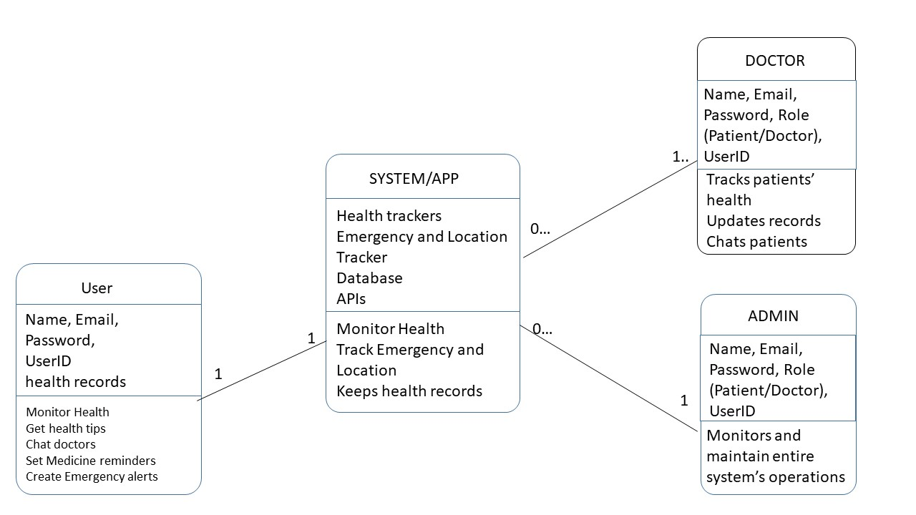

Figure 3. 2 ER Diagram

The following entities are part of the Health Monitoring System's Entity-Relationship (ER) model:

1. User: Some of the information is as follows: Name, Email, Password, Role; Patient/Doctor, User ID.

2. Health Data: The attribute includes Data ID, User ID, Heart Rate, Blood Pressure and the Timestamp.

3. Health Tips: Some of the attributes include; Tip Text the ID of the user who made the tip, User ID the ID of the tip given, Tip ID and Date/Time the tip was deposited in the system, Timestamp.

4. Medication Reminders: Some of the attributes include: Reminder ID, User ID, Medication Name, Dosage and Time.

5. Emergency Alerts: Alert ID, User ID, Location and Timestamp are among the attributes.

**Relationships:**

• User to Health Data Many to Many

• User-to-Health Tips: Individual to Group

• One to-Many User to Medication Reminders

• User to many emergencies Alerts

**3.8 Data Collection Methods**

1. User Input: The user has a special option to input the prescription schedule and health rules through the mobile application.

2. Mobile Sensors: Others include heart rate, smartphone sensors such as the camera will be used to take vital signs among others.

3. External Data Sources: If all the connected health applications and wearable devices are connected, we can be able to capture all the full records of our health.

**System Implementation**

Data analysis and process modeling are two methods that are quite popular within the field of organization science.

***Data***

|  |
| --- |
| **DATA ELEMENTS** |
| User data: |
| Health Data: |
| Health Tips: |
| Medication Reminders: |
| Notification data: |
| Message data: |
| Analytics data: |

***Processes***

|  |
| --- |
| **PROCESSES IDENTIFIED** |
| 1. User Registration: |
| 2. Content Creation: |
| 3. Track Emergency and Location tracking |
| 4. Health Monitoring |
| 5. Set Medicine reminders |
| 6. Updates records |
| 7. Messaging: |
| 8. Notification Management: |
| 9. Analytics and Reporting: |
| 10. Account Management: |

**Step 1: System Design**

The presentation on the Health Monitoring System design and implementation comprise of the architectural layout of the system, the graphical user interface, the main functionalities of the system, testing of the system and an overview of the functioning of the Health Monitoring System. Figure 3.3 is the Data Flow Diagram. In the design of the application, we did the following; User friendliness was considered so that users could manage to monitor their health status effectively and also in case of emergence.

• We adhered to the features and requirements of the system as set by our program.

• On our part, we created flow charts and system architecture graphs.

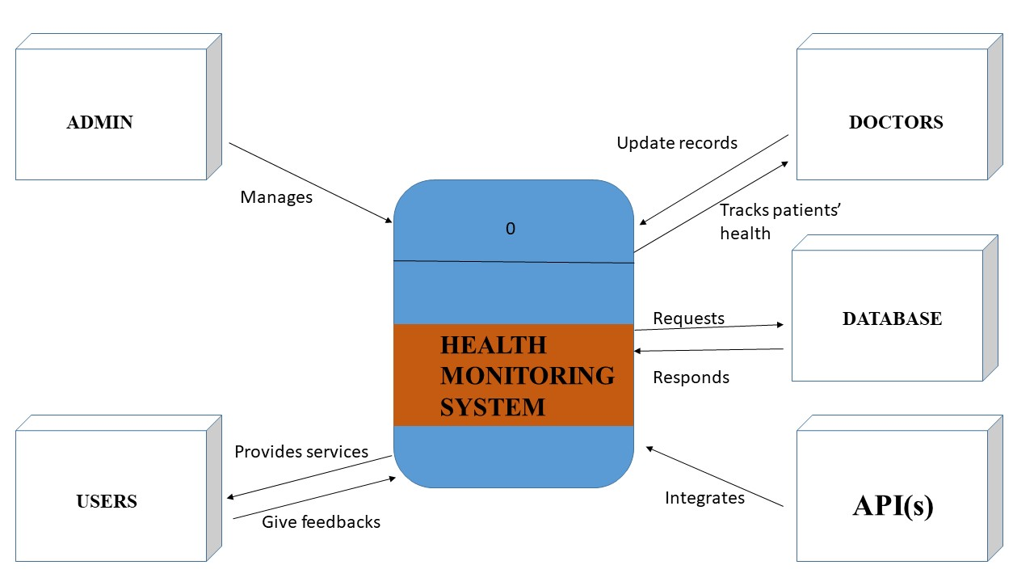

Figure 3. 3 Data Flow Diagram

**Step 2: Software Development**

• For as the server side of the application, we was responsible for the application logic, data processing and storage.

• The mobile application was designed to address the responsibilities of notifications as well as data visualization as well as the ability to address patients.

• It was we who designed the web application for keeping patient records and doctor-patient communication.

• Make the utilization of a database in health information storage.

**Step 3: Integration**

• We link the server side application to the web and the mobile applications.

• It must be convenient transferring data between the server, the web application, and the mobile application.

Figure 3.4 illustrates the Use Case Diagram of the system.

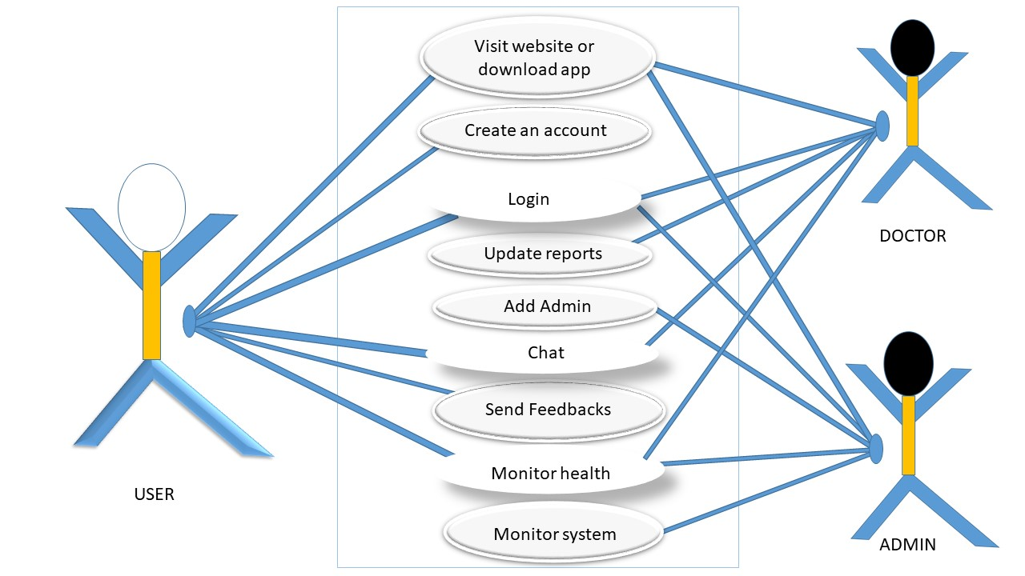

Figure 3. 4 Use Case Diagram

**Testing Procedures**

**Unit Testing**

• To ensure that the server-side, online and the mobile applications are working as they are supposed to, we made individual test.

• We have developed test scenarios and ratify the outcome for each module that we have developed. Integration Testing

• For services 2 and 3, we examined the functionality of the server-side application together with mobile and online applications.

• To emulate the data flow, we checked it especially for the server and the whole web application and the native mobile application.

**3.8.1 User Interface Design**

In spite of this reality, for the system under development, Health Monitoring System, the user interface was made interactive, easy to locate and was developed primarily, to provide the user with quick preference to certain data. As with the emergent cases, the suggested design allows the movement of the users around the system without much of a hassle.

**• Dashboard:** We created an initial page only containing the health profile of the user which has features of emergency preference and preferred healthy options. Dashboard ‘will behave like a health meter to give an exact picture of the health of the user.’

**• Login and Authentication screen:** This is a very simple and safe login page that facilitates the users who are allowed into the system.

**• Emergency Alert Interface:** This would be one interface through which the user could be modified to send an alert in case anything with few steps. It is intended to be as usable in this somewhat altered state of mind to as greater extent as is practicable.

**• Health Data Visualization:** The health data can be in the form of a graph which in its basic sense means that tracking is easily facilitated and also creates appreciation for dynamic visual patterns that are easily comprehended over time played a crucial role in the design of Health Monitoring System architecture and user interface, main functionality of the system, as well as the practical implementation of the Health Monitoring system. It will be a means through which the citizen’s response to health risks can be closely monitored in the case of an emergency. Response, and proactive health management so that it becomes easy for the users to monitor their response to health risks intelligently, in theevent of an emergency. The outcome of the system implementation is discussed in the next chapter where user and system performance feedback is taken into account.

**System Testing**  
• Testing needs to be carried out which will help in meeting the criteria of the whole system.  
• The stress testing also needs to be done to find out about how the system will function when it is under immense pressure.  
**User Acceptance Testing (UAT)**  
• Physicians and other users who may use the system must be allowed to test the system and provide feedback about the same.  
• Feedback coming from the users must be included to bring improvement in the various areas so that the usability and its functionality increases.  
**Evaluation Metrics**  
1. Accuracy: To check the level of accuracy in the health data received based on user inputs and mobile sensors.  
2. Reliability: the ability of the system to operate properly for a long period.  
3. User Satisfaction: To ask users how well the system works and how easy it is to use.  
4. Response Time: The time the system takes to process and display information.  
5. Scalability: Determine how far the system can support when data volume and user base  
 is increased

**3.9 Conclusion**  
This chapter introduces the systematic method of developing the Health Monitoring System. It also introduces the implementation of such procedures that could establish a reliable, easy-to-use, and effective system that would greatly improve users' health self-monitoring and management. A specific explanation of the detailed implementation procedure in the next chapter, including technologies used and challenges met, will be given thereafter.

**Chapter 4: Results and Discussion**

**4.1 Introduction**

This chapter gives the results achieved from the deployment of the Health Monitoring System which was subsequently accompanied by a discussion of the results. This chapter looks at how the system has evolved, the users’ insight as well as the influence on health management. The chapter also discusses some of the problems that could be met during the implementation process, and probable ways of solving them.

**4.2 System Functionality**

The Health Monitoring System is responsible for monitoring the health of the user alongside handling of emergencies in addition to providing for the total needs of the user.

**Admin/Doctor Functionalities**

The system shall also enable an admin user/doctor to monitor patient data at ease due to an interface simplicity. Following are some of the key functionalities of the Health Monitoring System that can be beneficial for an admin/doctor user:

**Doctor's Dashboard:** When a user logs in either as an admin or a doctor he is directed to his dashboard which resembles that of the figure 4.1 as shown below; It will also feature icons that will lead to other choices, the choices being patients’ information, emergency history, and status. Natural access has been stressed during its design and the monitoring of the data is done in real-time.

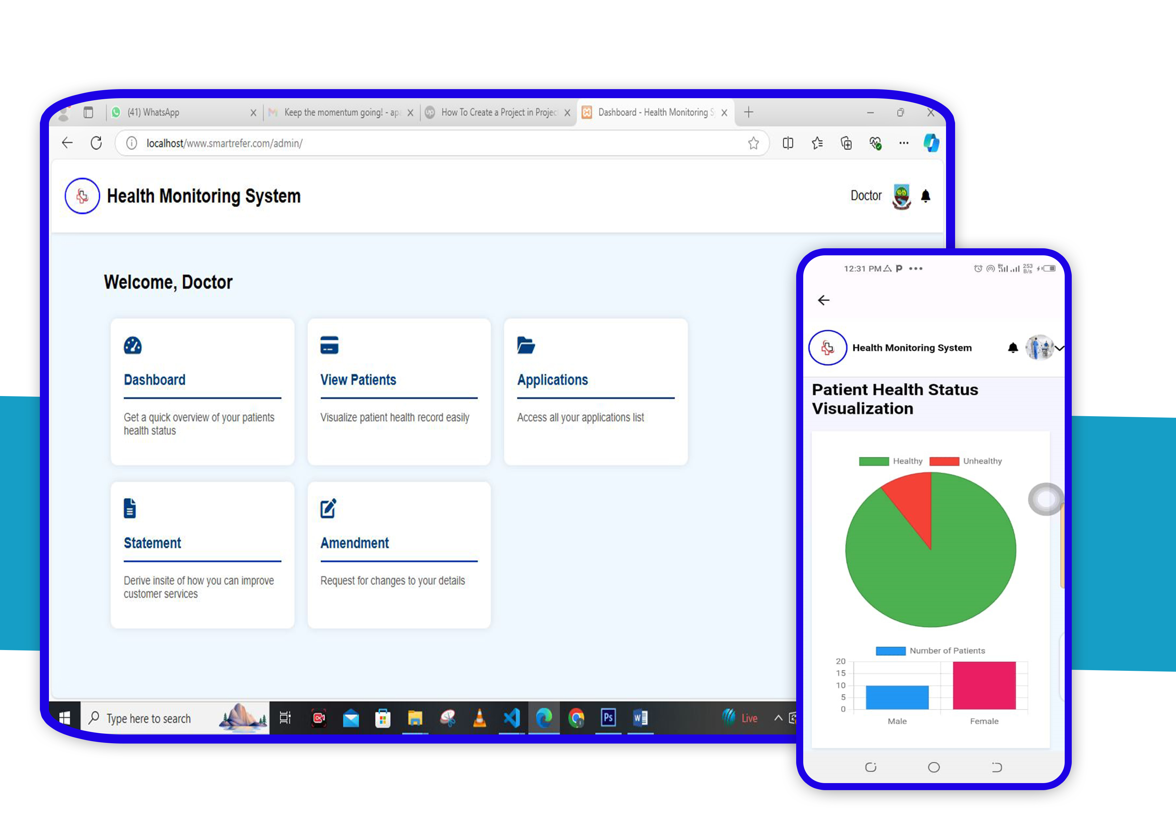

Figure 4. 1 Doctor's dashboard

**Analytics: Presents doctor with system overview shown in Figure 4.2**

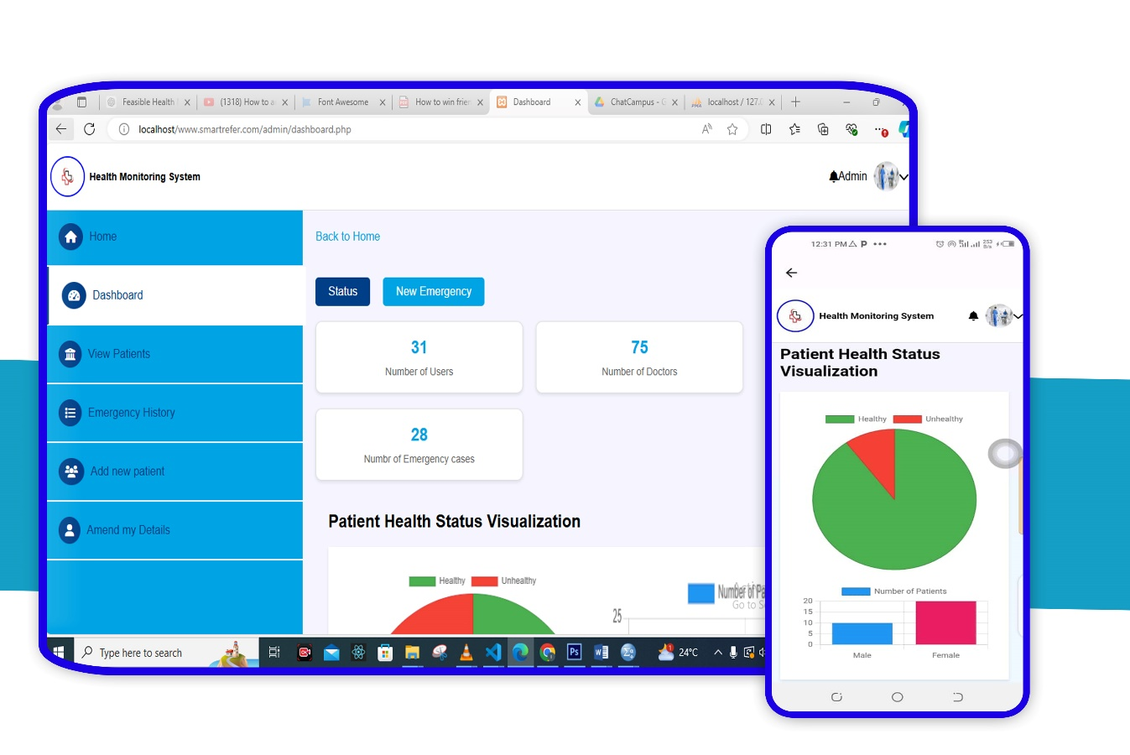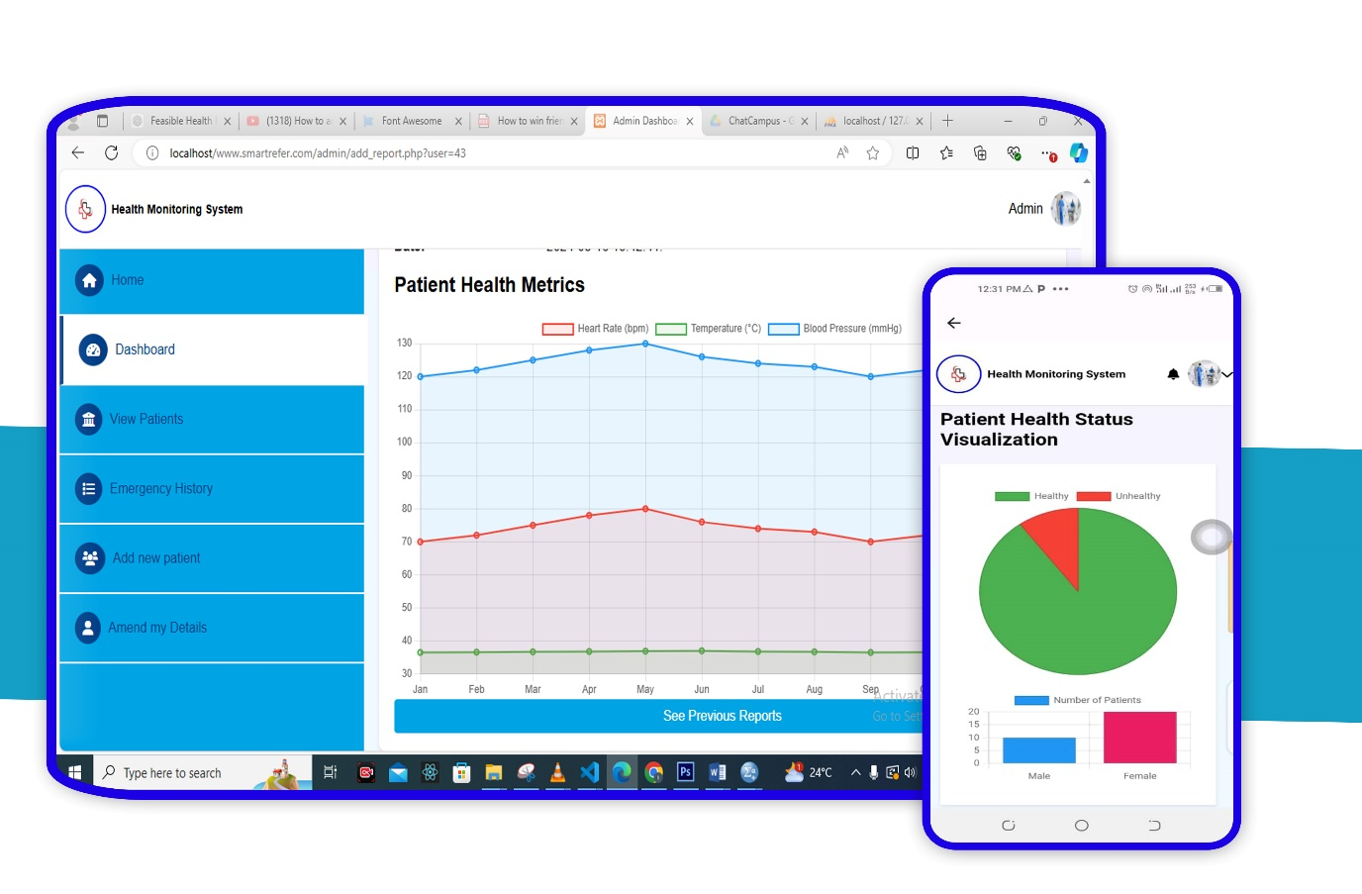

Figure 4. 2 System overview and analytics

**Patient Information:**  This interface shows a patient list from newest to oldest. On this "View Patients" tab in Figure 4.3, admins or the doctor can view detailed information about the patients.

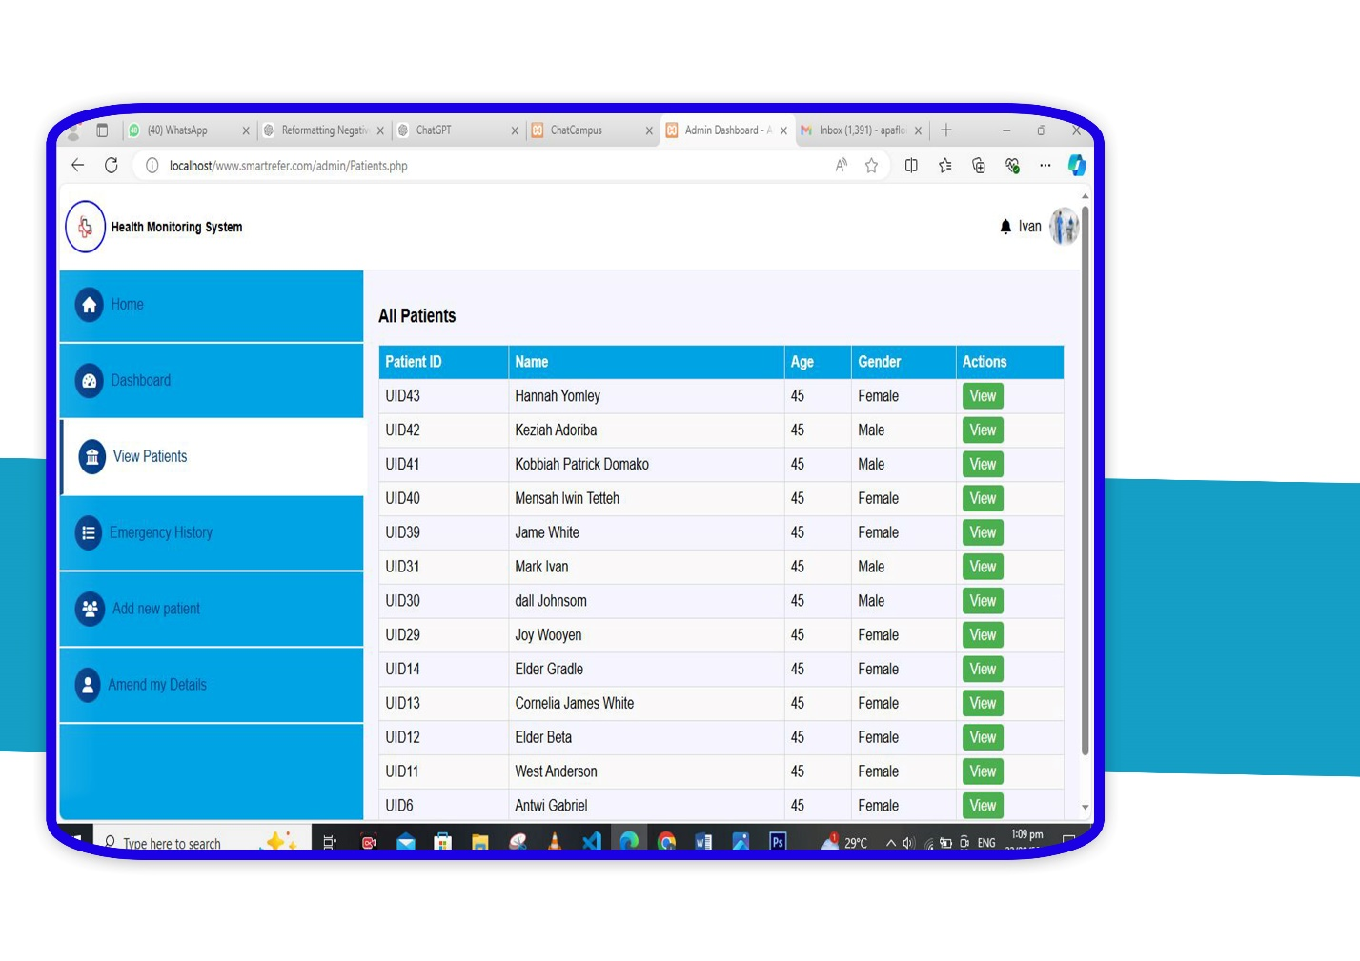

Figure 4. 3 Patient list

**Patient Record Management:** A patient record as illustrate in Figure 4.4 would contain information such as the patient’s name, age, gender and a reference number. It would also contain health status information such as glucose level, blood pressure, pulse rate, temperature, prescribed medicine etc. It will complete the history records of health as well as the graphical illustration of information of their current and their past medical history. The doctor can also decide to also make a live chat with the patient if the need arises. The system also enables the healthcare professionals to record the information of their patients in real-time so that any changes are being made if there is a need to.

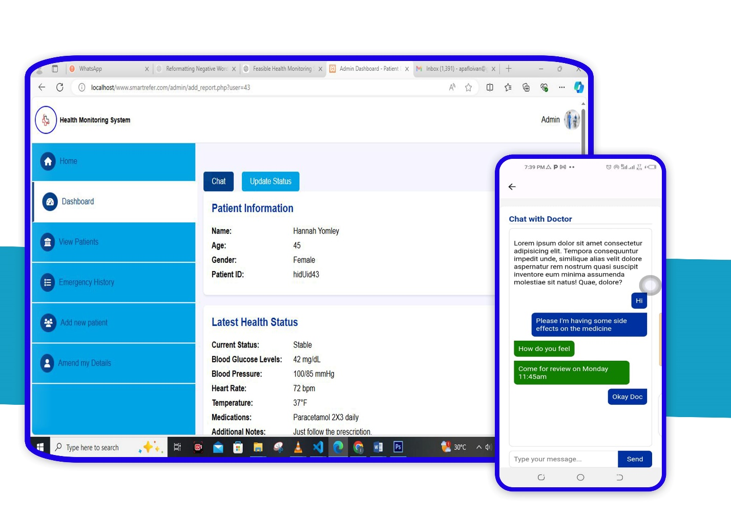

Figure 4. 4 Patient record

**Health Status Updates: By the “Update Status”, the possibility to change the health status of the patient is provided to a medical professional. In this feature the doctors can also enter new medical data, write prescriptions and make some other entries that would be useful in treating the patient. For example, as described in Figure 4.4, the last value found for a patient’s blood glucose level, blood pressure, and heart rate could be captured, as well as be updated.**

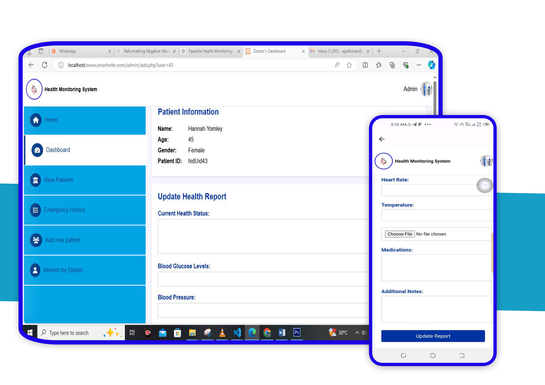

Figure 4. 5 Updating patient record

**Emergency History and Monitoring:** The "Emergency History" feature, Figure 4.6, logs the record of all emergency events. This record includes the date and time when an occurrence has taken place, the latitude and longitude of the geographical location in which the emergency had occurred, as well as the current status of the emergency response. It can be viewed by Admin and Doctor, who can further react to those that are yet unhandled upon tapping "React to case" for an emergency response on critical health incidences.

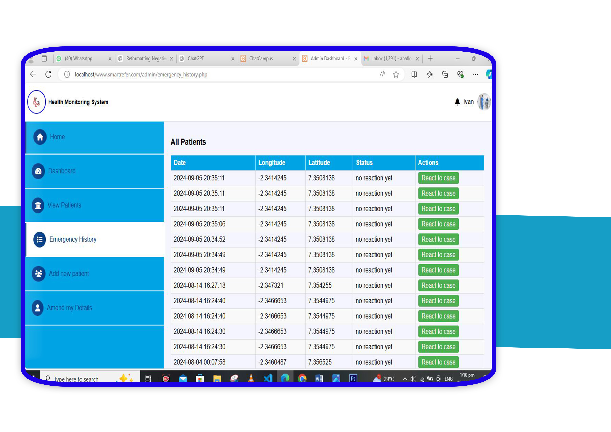

Figure 4. 6 Emergency list

**Integrated map: this helps doctors to track emergency cases as shown in Figure 4.7.**

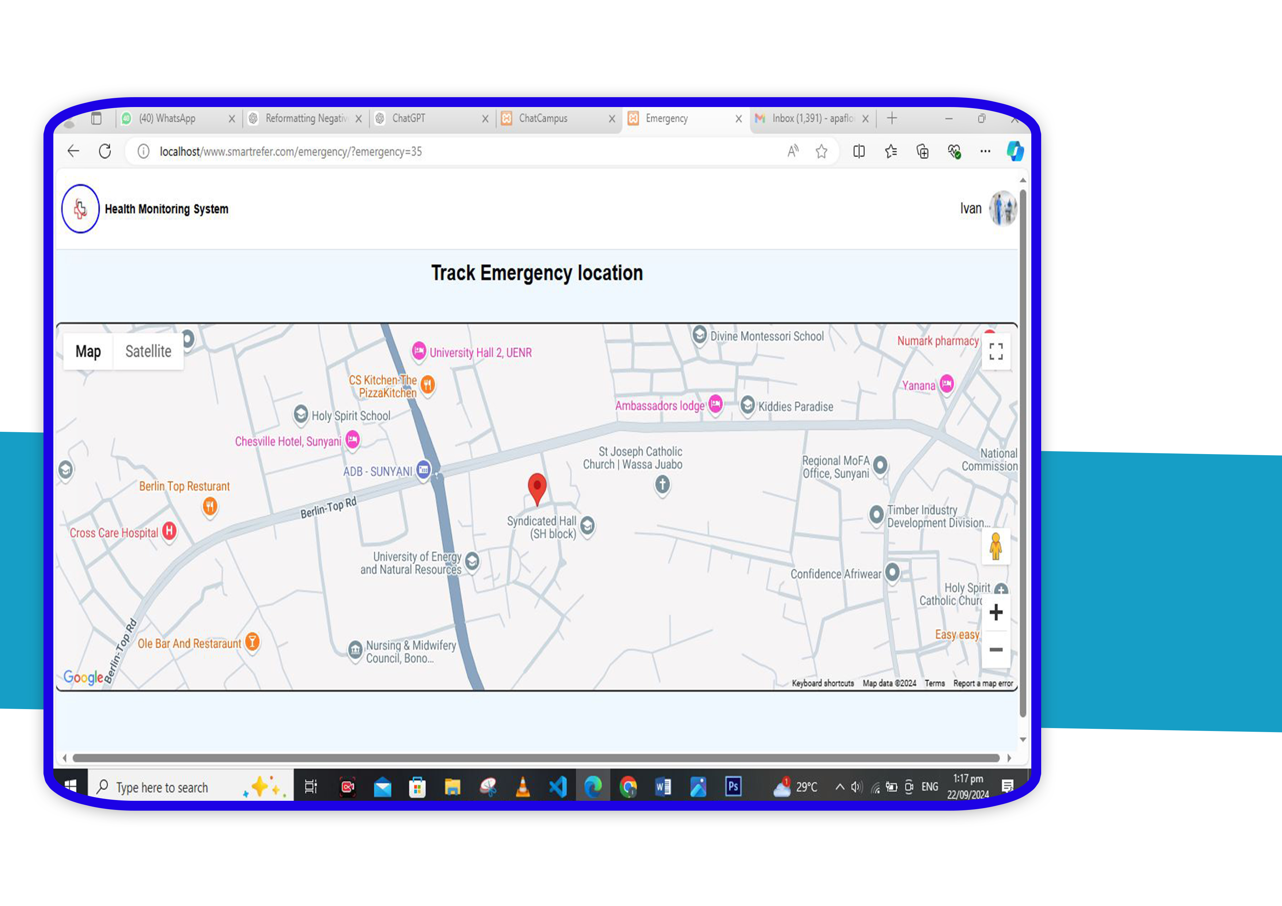

Figure 4. 7 Emergency tracking

**• Emergency Alert Interface:** that could make as bigger and as smarter as possible, so that it could be used in the quickest way possible with a minimum number of steps, so that even in very stressed situations it can be available as seen in figure 4.8 of the research. This feature is rather helpful for making sure the person can get the required medical help on time. In consequence, emergency alert can be generated, in which the contacts are informed of the location and general condition of the user.

### **User Functionalities**

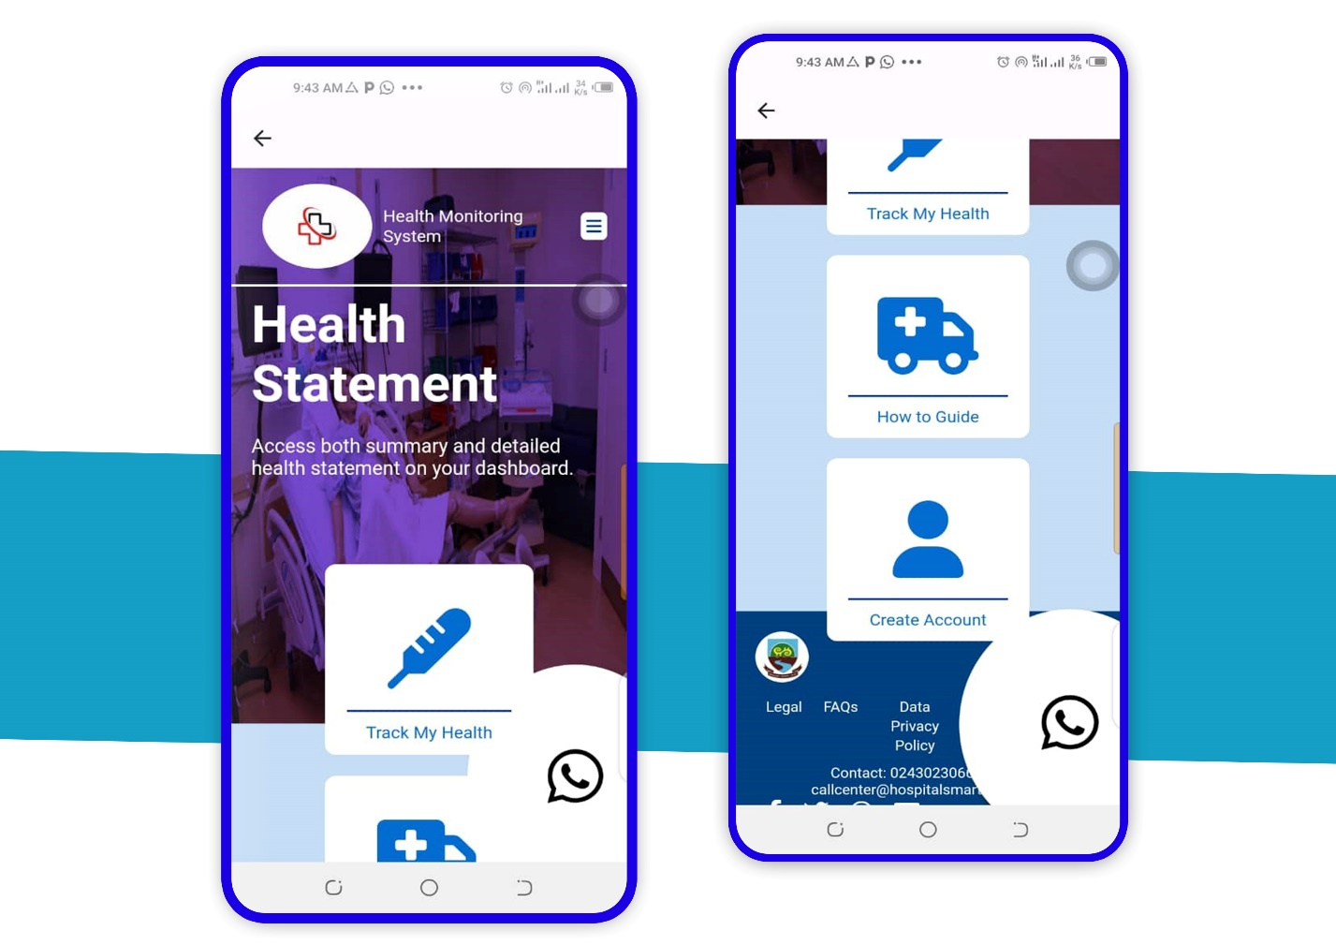

Figure 4. 8 Quick action and emergency alarming interface

**•Login and Authentication Screen:** has a basic yet safe home page so that only the allowed personnel can control every function of the system. In figure 4.9 is the home page of the login and sign Up page.

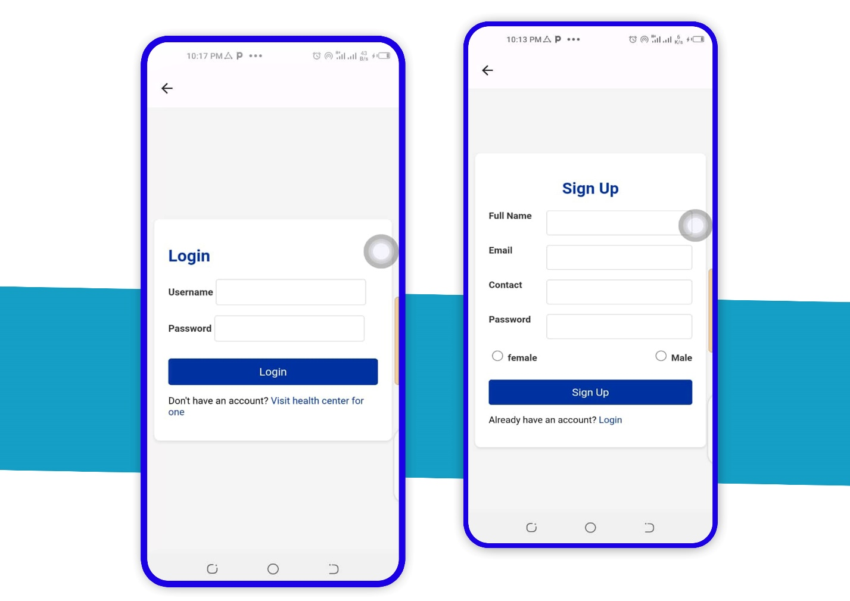

Figure 4. 9 Account creation and login

**• Dashboard:** the main interface from which users will be able to have a view of their current health metrics in real time, opens up to different types of emergencies, and get recommendations regarding the same as shown in figure 4.10. The information on the dashboard will be a clear, concise overview of your current status of health.

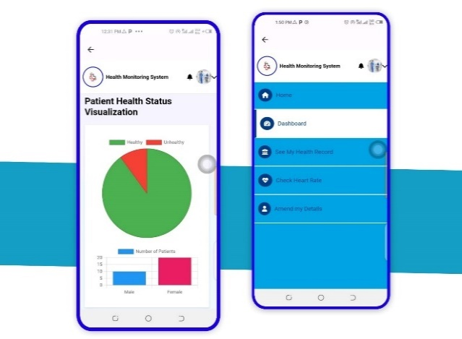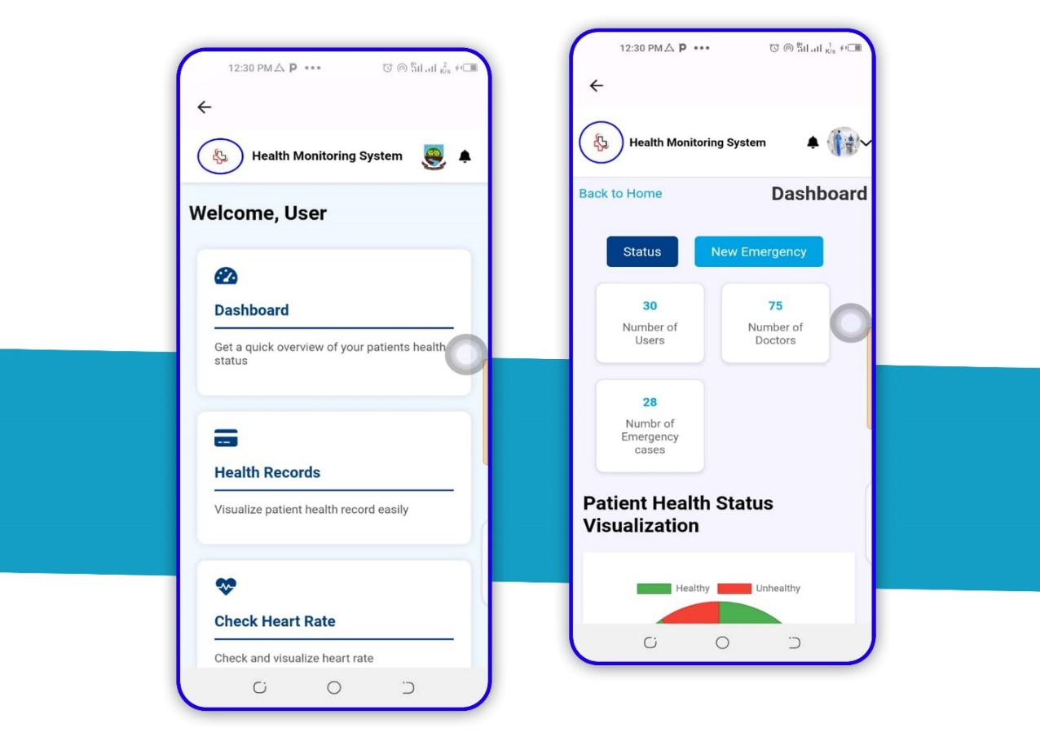

Figure 4. 10 User dashboard

**Real-time Health Monitoring:** Patients’ vital signs such as pulse rate and blood pressure are in real-time mode, and the system provides them with the responses. This will go a long way in helping early identification of any health complication. This is illustrated in fig 4.11 below.

* 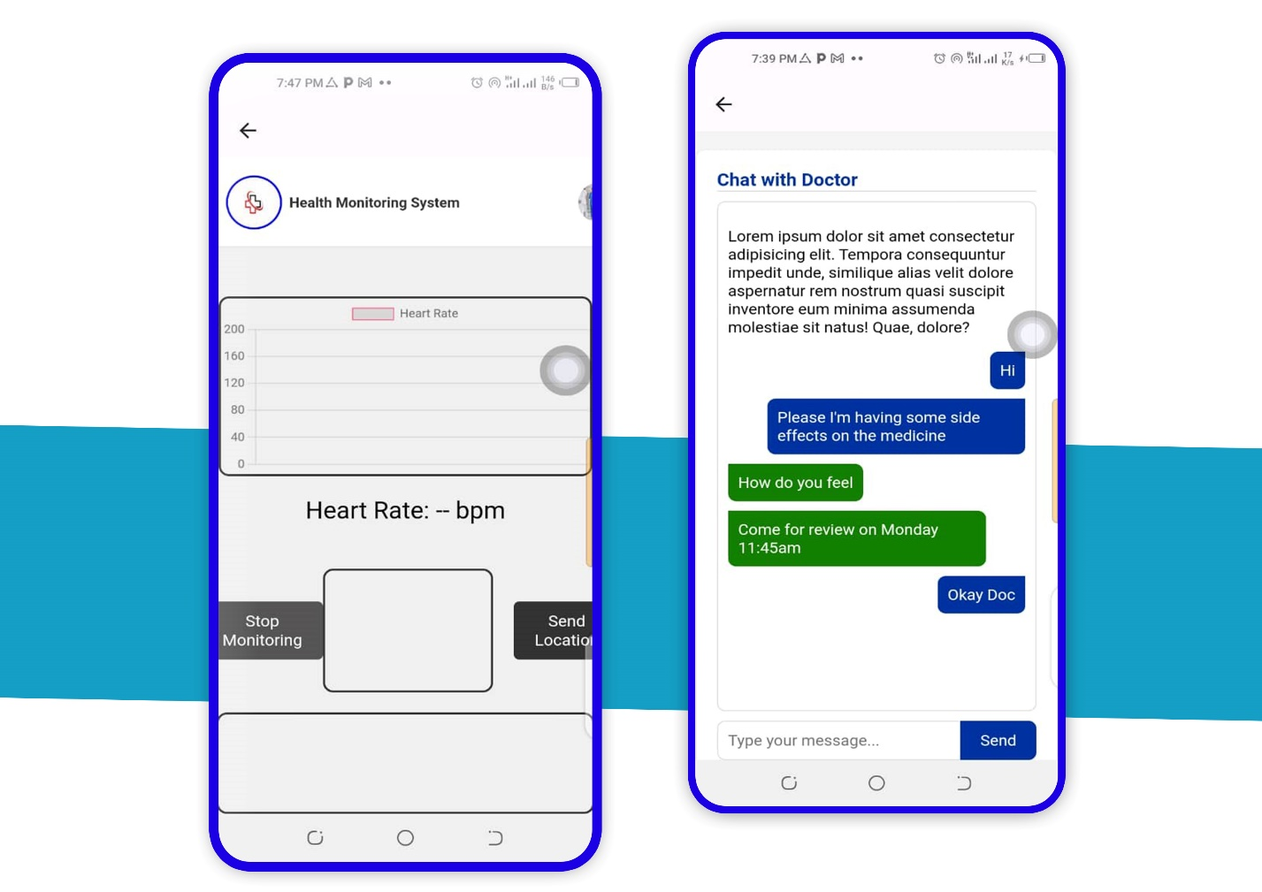

Figure 4. 11 Heart monitoring and real-time chat with doctor

**Health Data Logging:** The system logs health-related data that users can use in monitoring their personal health metrics. The information gathered serves many purposes towards long-term health management and may also be shared with healthcare providers as shown in Figure 4.12.

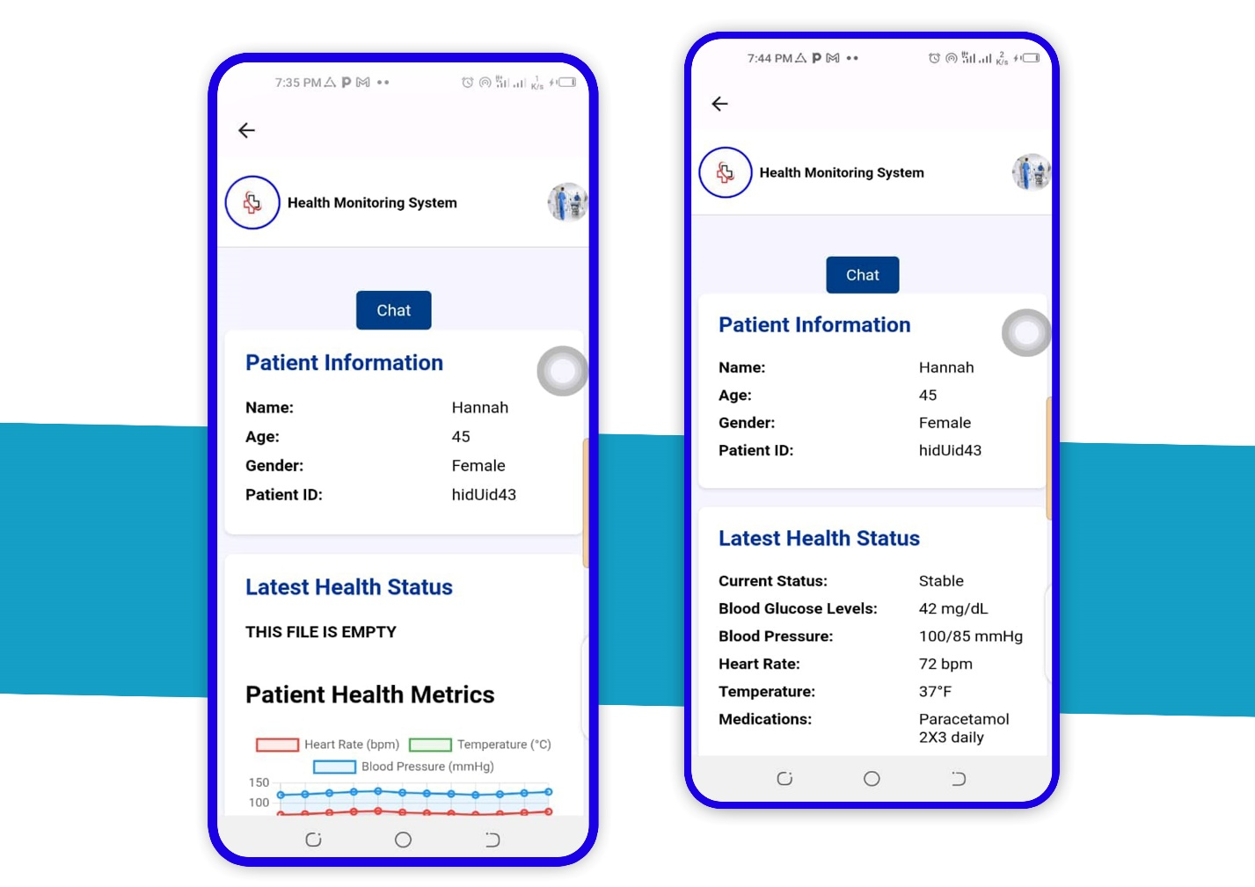

Figure 4. 12 User health records

* **Medication Reminders:** the system reminds users to take medication at the right time so users do not forget and thus skip a dose shown below in Figure 4.13.

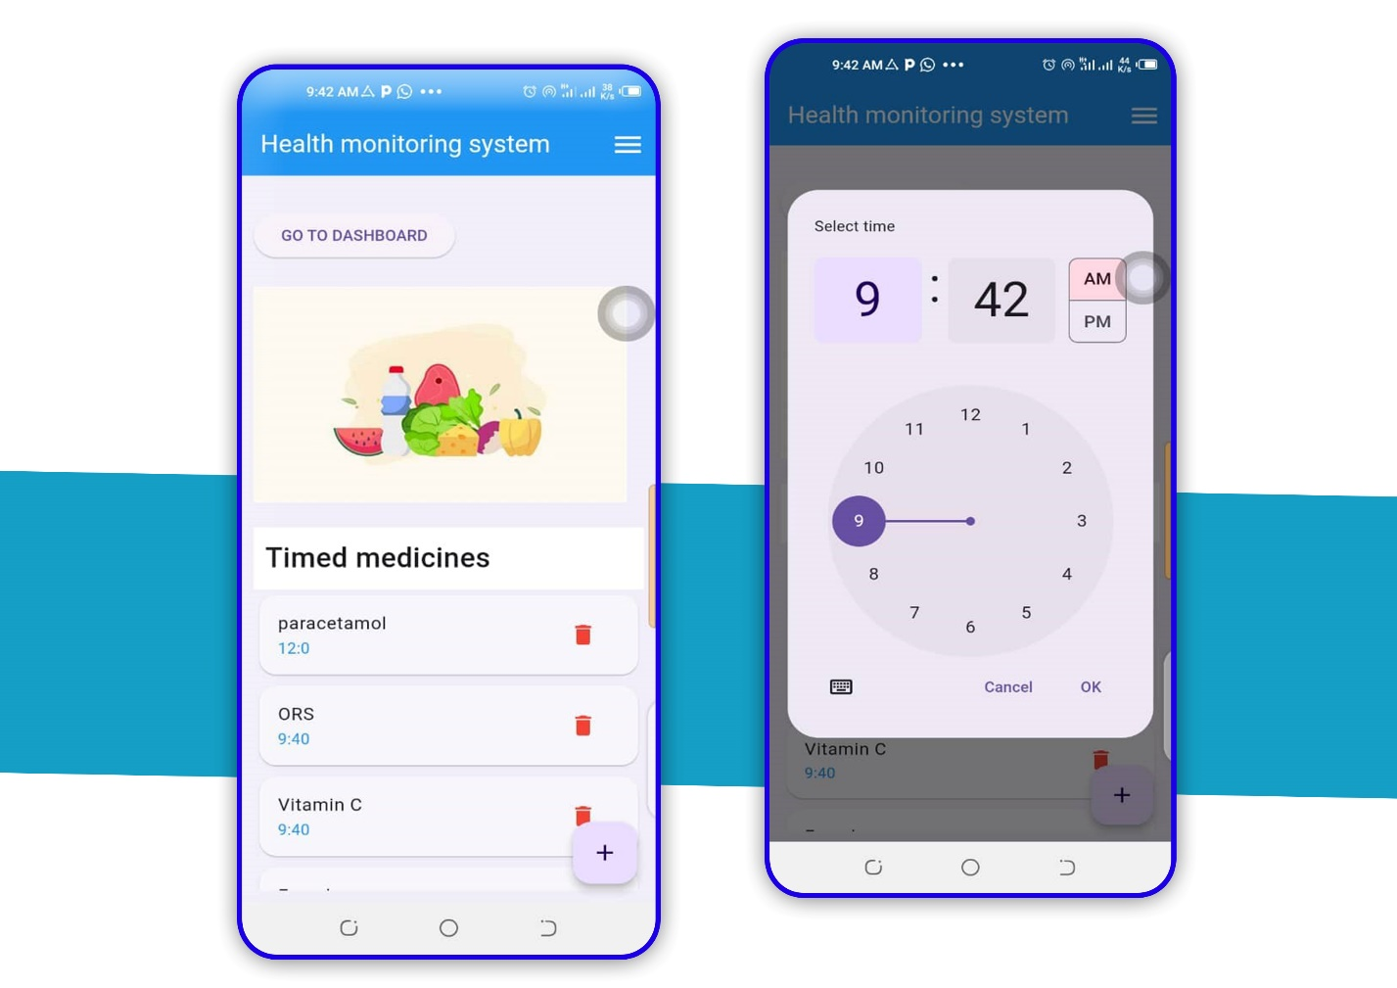

* Figure 4. 13 Medication Reminder

**4.3 Testing of the System and Evaluation.**

The team worked hard testing the Health Monitoring System to make sure it does everything it is supposed to, both in how it works and how it does not work. Some of the test cases include:

**• Usability Testing:** All the above is about making the system to be easy to operate by the end users bearing in mind that most of them may not be computer experts. Thus, it means that the interface had to be tested whether it was easy to find its way in the interface.

**• Performance Testing:** Part of the evaluation was to seek views on how the system would effectively operate at such times when there is congestion or higher demands for real time updates.

**• Security Testing:** Due diligence is conducted in order to ensure it complies with all the rules of privacy.

**• Compatibility Testing:** We wanted to ensure that the system is easy to run on various devices and operating systems for enhanced experience.

**4.4 System Performance**

The performance of the system has been evaluated based on a few important key parameters-response time, accuracy in the monitoring of health data, and reliability of the emergency alert system.

**• Response Time:** The taken response time by the Health Monitoring System was very fast. In fact, data updates in this system on a real time basis in a sliver of a second possible in millisecond. It is such a quick response must give consideration to be made particularly in the event of an emergency.

**• Accuracy of the health data**: The reliability of the data on health, provided by the system, was confirmed by comparing it with standard tools of medical equipment. From the results it is seen that within the error limit, the system functions as effective tool in the daily health monitoring applications.

**• Reliability of Emergency Alerts:** Experiments were performed on the system concerning emergency alert developed in order to assess its performance under different circumstances. The potential which was demonstrated under all these conditions was that under each of them the system was perfectly normal and delivered the precise geographical coordinates and the vital signs every time to the list of contacts to be informed.

**4.5 Discussions of Findings**

The section of the discussion is an evaluation of results from a standpoint presented from the goals and objectives defined at the start of the project. The comparison of these findings with those of other authors or of existing systems is also carried out in this section.

**• Improved Health Monitoring:** In addition to allowing checking of the actual, instantaneous level of health, the ability to log the values for later analysis puts the system in the category of the next generation of personal health management.

**• Efficiency in Emergency Response:** The installed emergency response system is presented as an achievement in whole of the project. The time that is covered waiting for help in the critical statuses of life and death is lesser since it assists in making the users deliver notifications to the required contact abetment with all the necessary accuracy and speed as soon as possible

**• User Engagement and Behavioral Change:** Positive user feedback suggest that the system offer more than today’s technical specifications and enable users to be proactive about their health. The system enables users to receive an ongoing feedback from the created interventions and innovations.

To take immediate actions based on their health data which over time would result in better health outcomes.

**• Comparison with Existing Solution:** It was designed to join the features of real-time monitoring, emergency response, and data logging in such a way that these would support each other. Contrary to this, in already existing health monitoring systems, different aspects may be witnessed. While some similar characteristics are present, the combination and accessibility of this system make it unique compared to the rest.

**4.6 Summary**  
This chapter has discussed the implementation results of the system, focusing on its performance, the satisfaction of users, and the health management consequences. The study results show that the Health Monitoring System is particularly useful in real-time health data provision, it has attained improvement in emergency responses and has appropriately engaged users in proactive health management

## Chapter 5: Conclusion and Recommendations

**5.1 Introduction**  
This final chapter summarizes the major conclusions of the research work done for studying the system, describes the contributions towards personal health management presented in this thesis, and following proposals regarding improvements in the system and recommendations concerning further theoretical developments. The chapter also discusses the limitations of the present system and some of the possibilities for improving the system and consequent usage in the future.

**5.2 Limitations of the Study**

Despite its successes, a few limitations are seen within the Health Monitoring System project:  
**•  Network Dependency:** Most of the processes used will be dependent on the performance of available networks, which are known to be slow in most geographical locations.  
**•  Battery Consumption:** Real-time monitoring and streaming of data in portable devices result in heavy battery consumption and hence render the system ineffective for continued use.  
**• User Adoption:** Although access to the system was uncomplicated, a number of the users had to be guided through it and the adults were most of those who had to be assisted. This needs to be taken in view of the level at which enhanced usability and interaction are required, by way of improvements in the user's awareness and easier deciphering of the interface.

**5.3 Recommendations for Future Work.**  
The recommendations for future development and research, therefore, considering the findings and limitations of the project, are as follows:  
**• Power Efficiency:** The Health Monitoring System should be modified in such a manner that, in subsequent models, much attention is paid to efficient use of batteries, perhaps with less power-consuming sensors and data transmission methods.

**• Enhancing Data Synchronization:** Stronger research methods in data synchronization could resolve problems where, due to poor network connectivity, health data gets cross-updated across devices.

**• Extending User Education:** This will make sure that a user can get access to the system no matter their tech skills

**• Discussion of AI Integration:** Addition of AI will further help this system even predict the possibilities of future health risks.

**• Enhancing Privacy:** Since users are really concerned about data privacy, future versions should be more concerned with advanced techniques that will help to gain more trust from the users.

**5.4 Conclusion**  
The Health Monitoring System presents a huge leap forward in managing personal health since it is a strong-enabling tool for users in real-time monitoring, emergency response, and data analysis.  
In the meantime, further refinement in its features and consideration of the limitations identified in this study is called for, while its efficiency and ease of operation have also been acknowledged. Efficiency in the system, extension of capability, and access to all users are areas that need enhancement in further research and development.

He, F. J., & MacGregor, G. A. (2010). Reducing population salt intake worldwide: From evidence to implementation. *Progress in Cardiovascular Diseases, 52*(5), 363-382. https://doi.org/10.1016/j.pcad.2009.12.006

Hoffbrand, A. V., Provan, D., & Measures, J. (2016). The history of folic acid. *British Journal of Haematology, 173*(3), 349-361. https://doi.org/10.1111/bjh.13924

Lee, I. M., Shiroma, E. J., Lobelo, F., Puska, P., Blair, S. N., & Katzmarzyk, P. T. (2012). Effect of physical inactivity on major non-communicable diseases worldwide: An analysis of burden of disease and life expectancy. *The Lancet, 380*(9838), 219-229. <https://doi.org/10.1016/S0140-6736> (12)61031-9

Mader, T. H., & Josephson, M. E. (1991). Spontaneous fluctuations in arterial pressure in response to exercise in hypertensive subjects. *Hypertension, 17*(2), 226-231. https://doi.org/10.1161/01.HYP.17.2.226

Micha, R., Peñalvo, J. L., Cudhea, F., Imamura, F., Rehm, C. D., & Mozaffarian, D. (2017). Association between dietary factors and mortality from heart disease, stroke, and type 2 diabetes in the United States. *JAMA, 317*(9), 912-924. https://doi.org/10.1001/jama.2017.0947

National Heart, Lung, and Blood Institute. (2022). Low blood pressure. Retrieved from <https://www.nhlbi.nih.gov/health-topics/low-blood-pressure>

National Institutes of Health. (2022). Tips for a healthy lifestyle. Retrieved from <https://www.nih.gov/health-information/healthy-living>

Rapid Application Development (RAD) model: An introduction to the three major types of databases that are used in today’s organizations. (2023). Retrieved from https://www.techopedia.com Sarnak, M.J., Levey, A.S., Schoolwerth, A.C., Coresh, J., Culleton, B., Hamm, L.L., & Wilson, P. W. (2003). Kidney disease as a risk factor for development of cardiovascular disease: A statement of the american heart association councils on kidney in cardiovascular disease, high blood pressure research, clinical cardiology and epidemiology and prevention. Hypertension, 42(5), 1050-1065. https:This article was published in Hypertension: //doi.org/10.1161/01.HYP.0000102971.85504.7c N Schneiderman, G Ironson, S Siegel, (2005). Stress and health: The various factors can be summarized as psychological, the behaviors demonstrated and biological factors. Annual Review of Clinical Psychology, 1, 607-628. https:>10.1146/annurev.clinpsy.1.102803.144141 Spruill, T. M. (2010). Hypertension and chronicle psychosocial stress. Current Hypertension Reports, 12(1), 10-16. https:Szugda P, Stojanovic M, Zivanovic S. Models of nursing care with family caregivers of persons with Alzheimer’s disease and related disorders: an integrative review. Journal of the American Geriatrics Society. 2009;57(8):1355–1369. Available from: doi:10.1007/s11906-009-0084-8 Data Structures & Algorithm Analysis of Entity-Relationship Modeling. (2022). Retrieved from https://www.dataversity.net Whelton, P. K., Carey, R. M., Aronow, W. S., Casey, D. E. Jr, Collins, K. J., Dennison Himmelfarb, C., … & Wright Jr, J. T. (2017). 2017 ACC/AHA/AAPA/ABC/ACPM/AGS/APhA/ASH/ASPC/NMA/PCNA guideline for the prevention, detection, evaluation, and management of high blood pressure in adults: Executive summary: A United states of America College of Cardiology/American Heart Association Task Force on Clinical Practice Guidelines. Hypertension, 71(6), 1269-1324. https:[3] Limiting processed foods and using the DASH diet to reduce hypertension can be accessed through the following link: <URL: http://doi.org/10.1161/HYP.0000000000000066

World Health Organization. (2021). Global health monitoring report. Retrieved from <https://www.who.int/health-monitoring-report-2021>

World Health Organization. (2023). Health topics. Retrieved from <https://www.who.int/health-topics>

Ghana Health Service. (2023). Facts and Figures. Retrieved from <https://ghs.gov.gh/facts-figures/>

Ghana Health Service. (2023). Ghana Bono East Region SNU Results. Retrieved from <https://ghs.gov.gh/wp-content/uploads/2023/12/Annex%20HHFA%20National%20Report%202023.pdf>

World Health Organization. (2019). Ghana Annual Report 2019. Retrieved from <https://www.afro.who.int/sites/default/files/2020-10/Ghana%20Annual%20report%202019.pdf>

PLOS Global Public Health. (2022). Noncommunicable Diseases in Ghana. Retrieved from <https://journals.plos.org/globalpublichealth/article?id=10.1371/journal.pgph.0000692>

DECLARATION

Keziah Adoriba, Mensah Iwin Tetteh, Armo Bright Amponsah, Kobbiah Patrick Adomako and Shardey Hannah Yomle jointly declare that this research study was conducted and written solely by us. We affirm that all sources of information used in this have been properly cited and acknowledged. We take full responsibility for any actions that might violate the research ethics policies of the University.

KEZIAH ADORIBA …………………… ……………………

(UED2708222) SIGNATURE DATE

MENSAH IWIN TETTEH …………………… ……………………

(UED2707822) SIGNATURE DATE

ARMO BRIGHT AMPONSAH …………………… ……………………

(UED2704022) SIGNATURE DATE

KOBBIAH PATRICK ADOMAKO …………………… ……………………

(UED2703622) SIGNATURE DATE

SHARDEY HANNAH YOMLE …………………… ……………………

(UED2703822) SIGNATURE DATE

MR. MICHAEL OPOKU …………………… ……………………

(SUPERVISOR) SIGNATURE DATE

PROF. DR. PETER APIAHENE …………………… ……………………

(HEAD OF DEPARTMENT) SIGNATURE DATE